Nalongsone Danddank Student ID : 14958950 StarID: jf3893pd
Email: nalongsone.danddank@my.metrostate.edu\

Homework 0 (14/15 pts)
- [5/5 pts]: Prove by mathematical induction that for all positive integers n,
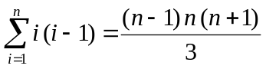
First, show the base case for this induction (2 pts).
Then state and prove the inductive step (3 pts).
Solution:
Show base case: proof when : n = 1
P(1) => 1*(1-1) = (1-1)*1*(1+1)/3 => 0 = 0 => P(1) is True.
State and Prove inductive step: show that any k >= 1, if P(k+1) True, then P(k)
Step 1: Assume that n = k true, then P(K) True:
On the left, 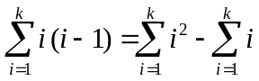 =
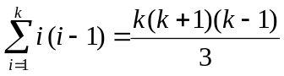
Step 2: show that n = k+1 true, then P(K+1) True
On the left side:
On the right side:
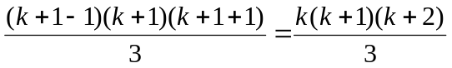
We can see that left side and right side is same So we prove that P(K) is True because P(k+1) is true following the inductive proof.
[5/5 pts] Describe how you would implement a stack using two queues. That is, for some object x of the appropriate type, describe how you would implement the standard stack methods push(x), pop(), and isEmpty(). You are given two queues, each of which has operations enqueue(x), dequeue(), and isEmpty().
You may do this with pseudocode or you may do it with an English-language description.
Solution:
Class Stack {
Queues<int> Q1 = new Queues();
Queues<int> Q2 = new Queues();
Void push( int x) {
If (Q1.isEmpty()) then { Q1.enqueue(x); }
else {
While (Q1.isEmpty() == false){
Q2.enqueue(Q1.dequeue()); }
Q1.enqueue(x);
While (Q2.isEmpty() == false){
Q1.enqueue(Q2.dequeue());
}
}
int pop() {
If (Q1.isEmpty()) then return null;
Else { return Q1.dequeue(); }
}
bool isEmpty() {
return Q1.isEmpty() && Q2.isEmpty()
}
}
[4/5 pts] How many dots will the following method print out as a function of n? I’m happy with a big-O estimate of this number. Note that this is written in pseudocode, not any particular programming language (although it follows C/Java-like syntax). Also note that the most important part is to explain your reasoning.
method3( int n ) {
for ( int j = 1; j <= 2^n; j++ ) {
for ( int k = 1; k <= j; k *= 2 ) {
print(“.”);
}
}
}

Answer:
We can see the first for loop will run by 2^n.
Then inside this for loop we have a net for loop which depend on j that come from the outside loop but it increase double every time so the time complexity should be log₂ j
So you need to carry this lg j through , see answer key.
So the total time complexity of this method is or the method print out is: 2^{n}(n-1) + n + 2
And the Big-O estimate = O(n*2^{n})

